DEALS TO PASADENA

Set against the stunning San Gabriel Mountains, Pasadena offers plenty of laid-back fun. While best known for hosting the annual Tournament of Roses Parade and Rose Bowl football game, there are also a wide variety of cultural activities and diverse shopping and dining experiences in the City of Roses. Book a trip to Pasadena via Los Angeles International Airport on Virgin America. Live it up at 35,000 feet with WiFi, on-demand entertainment, and more on every flight.

(MARKET IMAGE HERE)

Find Deals From These Cities

INSERT FARE GRID FROM / TO Version (if available!)

   
Top Things To Do in Pasadena

Whether you’re visiting for just a couple of days or for a longer period, check out some of these top things to do in Pasadena.

* Shop in Old Pasadena, a classic downtown area in the lively city of Pasadena. Its eclectic mix of hundreds of unique boutiques and retailers - all within walking distance - make it one of the premiere shopping districts in the country. It’s also one of Southern California’s most pedestrian friendly areas.
* Take in a comedy show at the Ice House. Open since 1960, the venue provides an intimate, no-frills space that pulls in many impressive acts. If you can make it on a Thursday evening, you’ll get a great deal with the club's popular $7 for seven comics showcase.
* Visit Pasadena’s largest park. Brookside Park provides a scenic green space with a lot to see and do. With a pirate ship-themed playground, the Rose Bowl Aquatics Center, various sports fields and facilities, picnic areas, and more, there’s undoubtedly something for everyone here. Don’t miss the actual Rose Bowl! Built in 1922 and recently renovated, “America’s Stadium” is home to the Tournament of Roses Football Game.
* The 36-hole Brookside Golf Course is just north of the stadium and should be a bucket-list item for any golfer.

Travel Tips and Resources

[Must-Dos in Pasadena http://www.tripadvisor.com/Attractions-g32859-Activities-Pasadena_California.html](http://www.tripadvisor.com/Attractions-g32859-Activities-Pasadena_California.html)

[Pasadena Hotels](http://www.tripadvisor.com/Hotels-g32859-Pasadena_California-Hotels.html)

[Pasadena Restaurantshttp://www.laweekly.com/restaurants/the-10-best-restaurants-in-pasadena-6468987http:/www.tripadvisor.com/Restaurants-g32859-Pasadena_California.html](http://www.laweekly.com/restaurants/the-10-best-restaurants-in-pasadena-6468987http:/www.tripadvisor.com/Restaurants-g32859-Pasadena_California.html)

[Pasadena Shopping Guidehttp://www.timeout.com/los-angeles/shopping/pasadena-shopping-guide](http://www.timeout.com/los-angeles/shopping/pasadena-shopping-guide)

[Pasadena Nightlife and Entertainment](https://pasadena.lanightlife.com/)

[Pasadena Travel Tips](http://www.fodors.com/world/north-america/usa/california/los-angeles/neighborhoods/pasadena-and-environs)

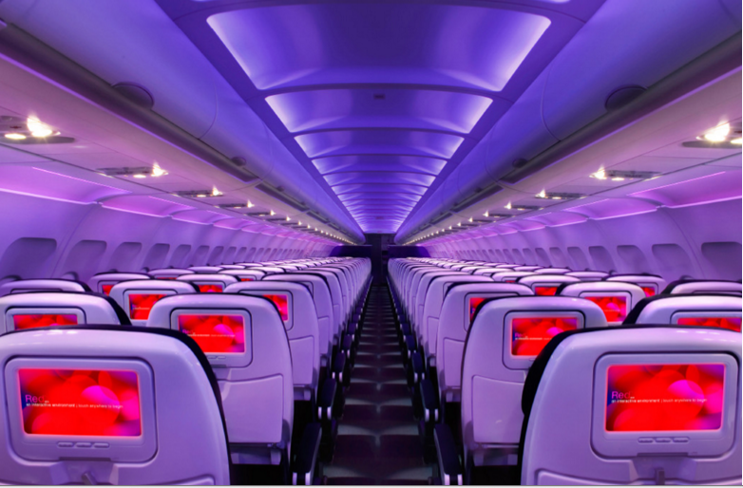

Main Cabin Main Cabin Select First Class

(add links to Cabin Class Pages)

Ready. Set. Fly.

Book your Mood-lit Ride to Pasadena.

Looking for flights to Pasadena? Located less than 30 miles from Pasadena, Los Angeles International is the closest airport to Pasadena, CA that services both domestic and international flights. Fly to Los Angeles with Virgin America and enjoy flying in style. Our custom-designed seats, mood-lit cabins, on-demand WiFi and entertainment, and other great amenities will provide you with a flight experience you’ll actually enjoy.

Take a Virtual Tour

Add Terms & Conditions